HANOI UNIVERSITY OF SCIENCE AND TECHNOLOGY

School of Information and communications technology

Installation Guide

Version 1.0

Eco Bike Rental Software

Subject: ITSS Software Development

Group 05

Nguyen Thai An – 20176677

Bui Tu Hoang – 20176761

Vu Minh Hoang – 20176765

Nguyen Manh Khang - 20176792

*Hanoi, November, 2020*

1. Hardware requirements

Hardware requirements to download Java on your Windows operating system as follows:

1. Processor: Intel Pentium IV 2.4GHz

2. Hard disk: 10GB Free

3. RAM: 4GB

4. Stable Internet connection

5.Mouse, keyboard, monitor and sound card, if required

1. Software requirements
2. At least JDK 14
3. JavaFx SDK 15.0.1
4. IntelliJ IDEA 2020.2.3
5. JDBC driver for PostgreSQL
6. JUnit 5
7. Database
8. PostgreSQL version 13
9. Installation and deployment step by step
10. Step 1: Unzip file EBR.zip, right click in folder EBR, choose “Open Folder as IntelliJ IDEA Project”
11. Step 2: Setup JDK and Libraries for project
    * In IntelliJ project, click “File”,choose “Project Structure...”.
    * In Project Structure, choose tag “Project” then choose one compatible JDK for the Project (at least JDK 14)
    * Choose tag “Libraries”, add 2 libraries: javafx-sdk-15.0.1, postgresql-42.2.18 (click button “+”, choose “java”, choose path to those 2 libraries, then click apply).
    * In the part of IntelliJ like the picture: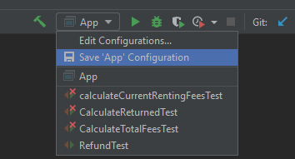

Choose “Edit Configurations...”, in the text field of VM option, enter “--module-path *“#PATH_TO_JAVAFX”* --add-modules javafx.controls,javafx.fxml” while *“#PATH_TO_JAVAFX”* is path to javafx library in your device.

1. Step 3: Setup database config:
   * Open “src/model/db/EBRDB.java”
   * In this field:add”: port” after” localhost” (” port" is your postgreSQL server port, 5432 is set to be default, you only need to add port if your port is not 5432).
   * Open “src/utils/Configs.java”
   * In this field: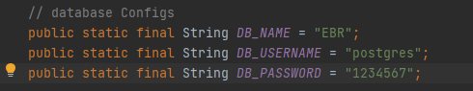

Change DB_NAME, DB_USERNAME, DB_PASSWORD to your own PostgreSQL server information.

1. Step 4: To run the program,

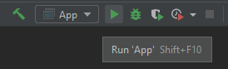

Click button “Run ‘App’ “or use combo Shift +F10